November 2022 Community Newsletter Content
How to Report a Crime
A message from the Federation of Calgary Communities

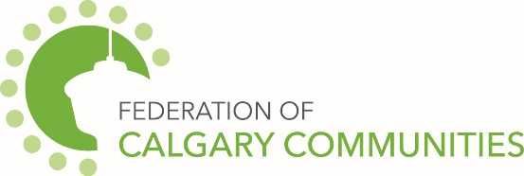

Reporting crimes committed against you or someone else is an important part in helping to keep yourself, your loved ones and your community safe. If you have information about a crime that has been or may be committed or about someone involved in committing a crime, your information may help the police solve crimes and prevent future crimes from happening.

You can report a crime in person, over the telephone and online. Depending on the urgency, choose the method that best suits your situation and makes you feel most comfortable.
911
- Emergencies or crimes in progress

Non-Emergency Line (403) 266-1234
- Non emergency crimes can be reported by calling the non-emergency line
- The Calgary Police Service encourages Calgarians to report all crimes, in order to identify trends and better direct their patrols

Citizen Online Police Report System (www.calgarypolice.ca)
- Report lost property or theft under $5,000 (except firearms, license plates or government-issued funds or ID)
- Report damage/mischief to property or vehicle under $5,000
- Report theft from vehicle under $5,000

District Office
- You can report non-emergency crime by visiting your district office. Location information at www.calgarypolice.ca

Drug Tip Line (403) 428-8100
- The Calgary Police Service takes calls from people who want to report drug related crime and wish to remain totally anonymous
- The Drug Tip Line is one way citizens can assist police by providing information and without having to identify themselves or testify in court

Crime Stoppers – Talk, Type or Text
- Call 1-800-222-8477, submit tips online at crimestoppers.ab.ca or text tttTIPS to 274637
- Crime Stoppers is a non-profit organization that takes calls from people who want to report a crime and wish to remain totally anonymous
311
- Report graffiti to the City of Calgary

City of Calgary Content
The November 2022 Community Newsletter content has been posted at https://www.calgary.ca/communities/newsletter-content.html
This month’s topics include:
- Green Line update
- Online map for Business Improvement Areas

