January 2023 Community Newsletter Content
Protect Yourself From Identity Theft
A message from the Federation of Calgary Communities

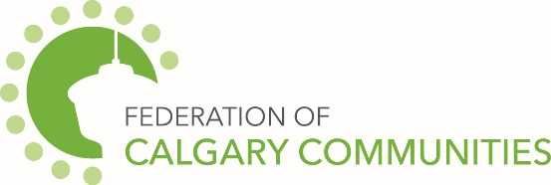

Identity theft occurs when your personal information is collected and used by persons without
authorization to do so.

The result of this illegal activity includes, but is not limited to, applications in your name being made for credit with financial institutions, retail outlets, mortgage companies, etc. Once your identity is compromised, it may take tremendous amounts of effort on your part in order to restore your good name and credit rating.

Tips on how to reduce your chances of becoming a victim of identity theft include:

- Before you reveal any personal identifying information, find out how it will be used and if it will
- be shared with others.

- Pay attention to your billing cycles. Follow up with creditors if your bills do not arrive on time.

- Guard your mail. Deposit outgoing mail in post office collection boxes or at your local post office. Promptly remove mail from your mailbox after delivery. Ensure mail is forwarded or re-routed if you move or change your mailing address.

- Utilize passwords on your credit card, bank and phone accounts. Avoid using easily available information
- such as your mother’s maiden name, your birth date, the last four digits of your SIN or your phone number.

- Minimize the identification, personal information and number of cards you carry.

- Do not give personal information on the phone, through the mail or over the internet unless you
- have initiated the contact or know with whom you are dealing.

- Keep items with personal information in a safe place. An identity thief may pick through your garbage or
- recycling bins. Be sure to tear or shred receipts, credit applications, insurance forms, physician
- statements and credit offers you get in the mail.

- Give your SIN only when absolutely necessary. Ask to use other types of identifiers when possible.

- Do not carry your SIN card or birth certificate; leave them in a secure place.

- Become familiar with schemes such as Phishing and Vishing which are designed to glean personal information from you via the Internet or telephone.

Reference: Calgary Police Service. (n.d.). 16032-CalgaryScamsBooklet. In CalgaryScamsBooklet 1F LowRes.

