2022 Community Newsletter Content
Enhance your community with ActivateYYC
A message from the Federation of Calgary Communities

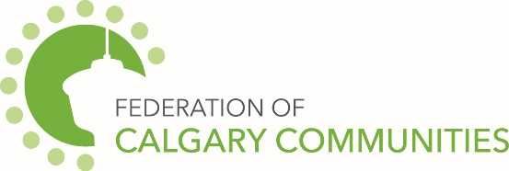

Engaging community members, revitalizing neglected spaces, calming traffic, improving the feeling of safety and promoting diversity and culture are all things that can be enhanced in your community through an ActivateYYC microgrant.
You can partner with a Calgary community organization, community association, local business or business revitalization zone and apply for one of ActivateYYC’s two grant options.
We have a $1000 Walk, Play and Be Neighbourly grant if you’re interested in doing something that will mobilize people to move differently in your community, re-imagine space into place or create a sense of neighbourliness. In the past, communities have used this grant to host events, paint murals, install little free libraries, etc. The sky is the limit!
We also have a $3000 Bump Outs and Pathways grant if your idea is focused on encouraging traffic calming, accessibility, safety and walkability. This grant can be used for projects on non-bus route residential streets or neighbourhood pathways. In the past, communities have painted bump outs on street corners, painted bike lanes, etc. Anything to slow car traffic and allow pedestrians, bikes and scooters to reclaim the streets.
This year, application intake is ongoing until August 15 or funds run out. So, if you have an idea for a small temporary low-cost project, apply fast! To get inspired by past projects, learn more about the application process and fill out an application form, visit https://activateyyc.calgarycommunities.com/.
Be Part of It!
City of Calgary Content
The July 2022 community newsletter content has been posted at: https://www.calgary.ca/cfod/csc/community-newsletter-content.html.
This month’s topic is:
- The Parks Wayfinder Map can help you find park amenities like washrooms and firepits.

