May 2022 Community Newsletter Content
Spring Cleaning
A message from the Federation of Calgary Communities

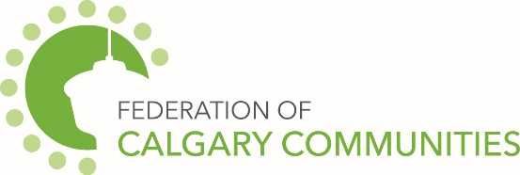

Did you know that the City of Calgary helps support community associations in helping residents clean up the neighbourhood! Residents can attend their Community Cleanup event and throw out waste saving you a trip to the landfill.
The service is free, and the purpose is for items that are not acceptable or do not fit in the regular waste (black carts) and recycling (blue carts) to be taken during a Community Cleanup. You can call your community association or go online to the official City of Calgary website.
Acceptable items include,
- Furniture
- Yard waste (organic trucks will be available)
- Broken unusable products like gym equipment
- toilets
You and your neighbours can organize a Litter clean up. The City of Calgary provide kits that include garbage bags, gloves, and hand sanitizer. You can pick up these kits at city leisure and aquatic centres.
You can get outside, meet neighbours and achieve a cleaner community at the same time!
Happy Spring Cleaning!
City of Calgary Content
The May 2022 community newsletter content has been posted at: https://www.calgary.ca/cfod/csc/community-newsletter-content.html.
This month’s topics are:
- The City of Calgary has a map that shows where off-leash areas are.
- World Bee Day is May 20. Find tips on how to create a habitat for bees.
- Help build a resilient watershed with YardSmart garden beds.

