December 2020 Community Newsletter Content
Think Safety
A message from the Federation of Calgary Communities

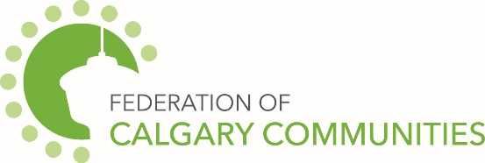

We live in a society where we expect to be safe. We have paid professionals in every walk of life from law enforcement, healthcare, etc. whose job it is to ensure our wellbeing. However, we must empower ourselves through knowledge and action and take responsibility for our own personal safety. Awareness and avoidance are important elements of a safe strategy which can be blended seamlessly into your lifestyle.
Have a Personal Safety Strategy:
- Know that a danger could exist and never forget it.
- Admit to yourself that you could become a victim.
- Have a plan. Know what you will do if a dangerous situation comes up. Be determined not to “freeze up.”
- Be suspicious. Too much “faith in human nature” can make you an easy target for a vicious criminal.
- Trust your good judgment. Common sense is the best protection
City of Calgary Content
The December 2020 community newsletter content has been posted at: https://www.calgary.ca/cfod/csc/community-newsletter-content.html
This month’s topics are:
- Safety during the festive season
- Winter holiday fire safety
- Youth Employment Centre
- Connect with The City of Calgary

