September 2020 Community Newsletter Content

Make a Difference in Your Community!
A message from the Federation of Calgary Communities

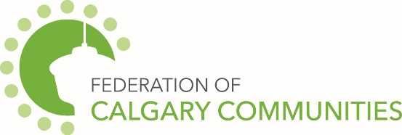

Volunteering with your community association and contributing your unique skills and knowledge, alongside your volunteer team, helps your community thrive! Your volunteer efforts are critical to making a difference in the quality of life in your community and helping to build a sense of belonging.
Not only does your community benefit from your volunteer efforts, but you do too! Check out some of the personal benefits of volunteering in your community below!
- Connect with New Friends and Your Community
- Meet new people with shared interests
- Enhance your skills in building relationships
- Strengthen community connections, broaden your support network, and access neighbourhood resources and fun activities

- Benefit Your Mind and Body
- Reduce stress, improve self-confidence and increase happiness and a sense of purpose
- Increase physical activity to support a healthy body and mind

- Help Advance Your Career
- Enhance and develop new skills
- Gain valuable career experience

- Have Fun!
- Explore your interests, make time for hobbies (e.g., help plant a community garden), renew your creativity and fulfill personal goals
- Enjoy social activities with new friends

- Make a Difference
- Give back to and strengthen your community
- Have a positive impact in peoples' lives - it is one of the most rewarding volunteer experiences!
Learn more about community associations at calgarycommunities.com/about-communities.
City of Calgary Content
The September 2020 community newsletter content has been posted at: http://www.calgary.ca/cfod/csc/Pages/Community-newsletter-content.aspx

This month’s topics are:
- COVID-19: Staying open is in your hands
- Festival and Event Microgrant program
- City Map Gallery: Solar Potential Map

