August 2020 Community Newsletter Content

Around the Block, Let’s Walk
A message from the Federation of Calgary Communities

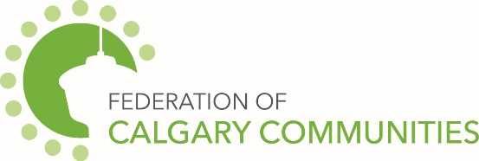

Walking is a great form of cardiovascular exercise, but did you know it can also be an opportunity to increase safety in a neighbourhood? Walking around your neighbourhood, whether it’s with a family member, dog, or by yourself, can help to make your neighbourhood safer.
Walking can help you get more familiar with your community, observe new things and trouble spots in the neighbourhood. While you walk you can survey poorly lit areas, is the signage in your neighbourhood adequate? Do the sidewalks and roads need maintenance? When you go for walks in your neighbourhood with these questions in mind you can easily spot areas that need attention.
When you’re out walking, don’t forget you can call 3-1-1 to report to City services, 9-1-1 for emergencies, or Calgary Police Service non-emergency line at (403) 266-1234 for non-urgent police concerns like noise complaints, minor accidents, etc. You can also connect with other resources like Safer Communities and Neighbourhoods (SCAN) about suspicious residential and commercial properties at 1-866-960-7226.
While walking, also keep a 2-metre distance between yourself and others. Please follow all current restrictions and suggestions from the City of Calgary and Alberta Health Services.

City of Calgary Content
The August 2020 community newsletter content has been posted at: http://www.calgary.ca/cfod/csc/Pages/Community-newsletter-content.aspx

This month’s topic is:
- Ready Squad talks Covid-19 safety

