July 2020 Community Newsletter Content

Bike Safety
A message from the Federation of Calgary Communities

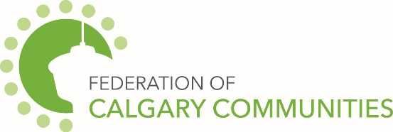

- Protect Your Noggin
Toddlers to adults should think twice before getting on a bike without a helmet. The helmet should fit nicely and cover the forehead. Calgarians under the age of 18 are required to wear a helmet.

- Ring, Ring!
Having bell can let those around you know your coming!
- Stop!
Being a cyclist follows similar rules to driving a vehicle. Pay attention to posted signs, speed limits and watch out for pedestrians. Know your route ahead of time it this can help you be aware of potential detours and hazards.

- Increase visibility
Having reflector or lights can increase your visibility for other cyclists, pedestrians and cars.

City of Calgary Content
The July 2020 community newsletter content has been posted at: http://www.calgary.ca/cfod/csc/Pages/Community-newsletter-content.aspx
This month’s topics are:
- Property tax information
- Summer storms
- YardSmart – using less water

