April 2020 Community Newsletter Content

Be Part of It! Benefits of Volunteering
A message from the Federation of Calgary Communities

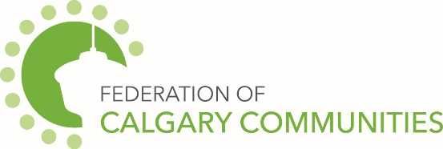

Volunteering with your community association and contributing your unique skills and knowledge, alongside your volunteer team, helps your community thrive!
Your volunteer efforts are critical to making a difference in the quality of life in your community and helping to build a sense of belonging. Not only does your community benefit from your volunteer efforts, but you do too! Volunteering can:
Connect to New Friends & Community:
- Meet new people with shared interests
- Enhance your social skills in building relationships
- Strengthen community connections, broaden your support network, access neighbourhood resources and fun activities
Benefit your Mind & Body
- Reduce stress, improve self-confidence and increase happiness and sense of purpose
- Increase physical activity to support a healthy body and mind
Help Advance your Career
- Build upon skills and develop new ones
- Gain valuable career experience
Have Fun!
- Explore your interests, make time for hobbies, renew creativity and fulfill personal goals
- Enjoy social time with new friends
Make a Difference
- Give back to your community
- Have a positive impact in people’s lives!

City of Calgary Content

The April 2020 community newsletter content has been posted at: http://www.calgary.ca/cfod/csc/Pages/Community-newsletter-content.aspx

Topics this month include:
- Registration of secondary suites
- Community clean up events
- Living with wildlife - tips
- Free home improvement information sessions
- Storm drains
- Water leaks
- Emergency plans for pets
- Recreation fee assistance
- Recreation Program Registration
- Calgary AfterSchool
- Birthday Parties
- Golf
- Recreation events and ongoing specials

Calgary Public Library Content
Meet your new Indigenous Artists in Residence
Tina Guyani (meaning “Deer Road” in Tsuut’ina) is the artistic collaboration of Glenna Cardinal and Seth Cardinal Dodginghorse. This mother and son duo were displaced from their home and ancestral land on Tsuut'ina Nation by the construction of the SW Calgary ring road in 2014. During their time at a Library, they’ll be researching Calgary’s historic pressure to sell the land and explore how construction affects communities. You can visit the pair in their Level 4 studio at Central Library on Wednesdays from 10:00 am to 2:00 pm, and even become part of their upcoming exhibit by sharing your stories with them. Learn more at calgarylibrary.ca/artists.

Need some space?
Find it at the Library! Whether you’re looking for a place to host a book club or condo board meeting, or you’re organizing a study group or community gathering, the Library has you covered. You can use your free Library card to book meeting spaces in 20 different locations for free. Every room is different, and offers an array of amenities, from workstations, to audio-visual connections and displays. Looking to create the next great podcast, web series, or video blog? We have specialized creative studios available to book as well. Get started today at calgarylibrary.ca/room-booking.

It’s Volunteer Week!
April 19-25 is National Volunteer Week. In 2019, 3,910 Library volunteers gave over 100,000 hours of aid to Calgarians, helping more than 85,000 patrons learn new skills, find information, explore technology, and make stories come to life. We couldn’t do what we do without the help of our volunteers, whose time and energy are valued at over $3 million annually. If you want to make a difference in the lives of Calgarians, consider joining our team at calgarylibrary.ca/volunteer.

