Neighbour Day 2020 Communications Content Package

Saturday, June 20 is Neighbour Day and we want you to be part of it!
We need your help to get the word out and get everyone involved in Neighbour Day! Let’s show Calgary the power of the community association network!
If you have not made any plans, do not worry- we’ve got you covered! Working with the Sunalta Community Association and the City of Calgary, along with some great feedback from our other members, we created an exciting scavenger hunt card! Click here to visit the City of Calgary’s website to download your scavenger hunt card, located at the bottom of the page!
Whether you are using our scavenger hunt card, or you have your own fun activity planned, we want all Calgarians to celebrate Neighbour Day 2020! And do not forget to use the hashtag #yycNeighbourDay so we can follow along on all the fun!

Not sure how to let your residents know about this activity or Neighbour Day? We have made it easy for you!
We have made it easy for you to encourage your neighbours and community to participate! See below for sample content you can use and easily customize to communicate to your neighbours and get everyone involved in this fun activity! Do you have your own activity planned? Feel free to customize the tweets to include your own activity!
Want more Neighbour Day communications content? Click here to download the City of Calgary’s Neighbour Day Communications Content!

*Please note that we cannot be referred to as the “FCC” as that acronym belongs to another organization. We either go by our full name or the “Federation” for short.

Images
Right click or screenshot to save an image to use for your social media, website, and email to your members!
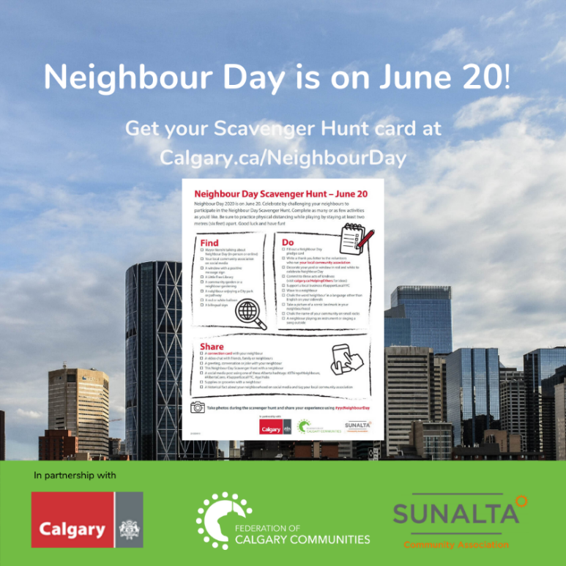
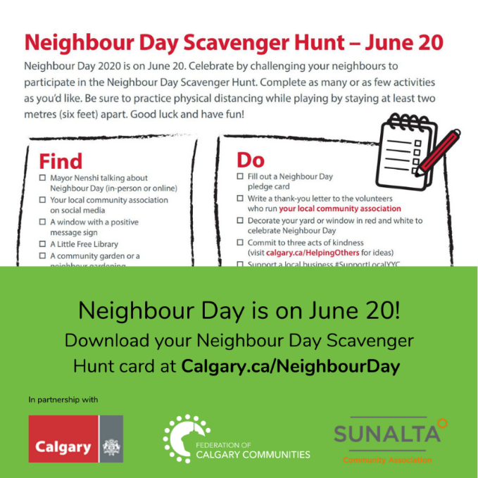

Outdoor sign messaging- If you can share a Neighbour Day message on your outdoor signs, please use the language below.

Neighbour Day – June 20
We’re celebrating a little differently this year.
Visit Calgary.ca/NeighbourDay

Sample website content

We want you to celebrate Neighbour Day with us on Saturday, June 20!
Join your [COMMUNITY NAME] neighbours in an exciting Neighbour Day Scavenger Hunt! Complete as many or as few activities as you would like, but do not forget to have fun and document it on social media using the hashtag #yycNeighbourDay and tagging us [social media handle if applicable]!
Let’s celebrate [COMMUNITY NAME] and our amazing neighbours! Find your Neighbour Day Scavenger Hunt Card, along with other fun activities, at Calgary.ca/NeighbourDay.

Sample email content to your members

Subject: Celebrate Neighbour Day in [COMMUNITY] on June 20!
Message: We love [COMMUNITY NAME] and our awesome neighbours- so let’s celebrate our community this Neighbour Day on Saturday, June 20!
We are taking part in a Neighbour Day Scavenger Hunt and we want you to join us! Complete as many or as few activities as you would like, but do not forget to have fun and document it on social media using the hashtag #yycNeighbourDay and tagging us [social media handle if applicable]! Download your scavenger hunt card at Calgary.ca/NeighbourDay.
However you choose to celebrate Neighbour Day this year, make Saturday, June 20 the day you get to know your neighbours from a safe physical distance in [COMMUNITY]!

Sample social media posts
Twitter handles: @fedyyc, @cityofcalgary, @SunaltaYYC
Hashtags: #yycNeighbourDay, #yycca
*Do you have your own activities planned? Feel free to edit these to suit your needs!

Date Specific
June 13
There is only one week until #yycNeighbourDay! Join us in celebrating [COMMUNITY NAME] and our awesome neighbours! Visit Calgary.ca/NeighbourDay to find fun activities and download your Neighbour Day Scavenger Hunt card! #yycca #bepartofit

June 19
Neighbour Day is tomorrow! Join thousands of our Calgary neighbours to celebrate #yycNeighbourDay! Not sure how to celebrate this year? Head to Calgary.ca/NeighbourDay to find fun activities! #yycca #bepartofit

June 20
Today is Neighbour Day! Join us in celebrating [COMMUNITY NAME] and our amazing neighbours! Are you on the hunt for some fun? Visit Calgary.ca/NeighbourDay to download your #yycNeighbourDay scavenger hunt card and get to hunting! #yycca #bepartofit

General

Neighbour Day is on June 20! #yycNeighbourDay is all about coming together and celebrating #yyc’s strong community spirit! So, lets celebrate [COMMUNITY NAME] and our awesome neighbours! Learn more about how you can be part of it on June 20 at http://ow.ly/9sW450A3bfi #yycca #bepartofit

One of the things we love most about [COMMUNITY NAME] is our awesome neighbours! Lets show Calgary how we are celebrating our neighbours and community on Neighbour Day on June using the hashtag #yycNeighbourDay! #yycca #bepartofit

We are excited to celebrate Neighbour Day on June 20 this year! #yycNeighbourDay is a great way to get to know our community and neighbours in [COMMUNITY NAME] better! #yycca #bepartofit

Join us in celebrating #yycNeighbourDay with thousands of our Calgary neighbours on June 20! Not sure how to participate this year? Visit Calgary.ca/NeighbourDay to download a scavenger hunt card and check out some of other fun activities! #yycca #bepartofit

#yycNeighbourDay is a great time to meet your neighbours, make new friends, have fun, and get to know your community better! And what better way to do that than with a scavenger hunt! Download your scavenger hunt card at Calgary.ca/NeighbourDay and explore [COMMUNITY NAME]! #yycca #bepartofit

@fedyyc, @SunaltaYYC, and the @cityofcalgary have developed a Neighbour Day Scavenger Hunt for June 20! Visit Calgary.ca/NeighbourDay to download your scavenger hunt and check out some of the other fun activities! #yycca #bepartofit

